**CANDIDATES NAME:…………………………………………………………………**

|  |  |  |  |  |  |  |  |
| --- | --- | --- | --- | --- | --- | --- | --- |
| **INDEX NUMBER** | | | | | | | |
|  |  |  |  |  |  |  |  |

**SIGNATURE: ……………………………………**

**456/1**

**MATHEMATICS**

**PAPER 1**

**JUNE/JULY**

**2 HOURS**

**MOCK EXAMINATIONS SET 1 2019**

**Uganda Certificate of Education**

**MATHEMATICS**

PAPER 1

2 HOURS

**INSTRUCTIONS TO CANDIDATE:**

* *Answer all questions in section A and any five questions from section B.*
* *Any additional question(s) answered will not be marked.*
* *All necessary calculations must be done on the same answer sheets with the rest of the answers.*
* *Silent non – programmable scientific calculators and mathematical tables with a list of formulae may be used.*

**SECTION A:**

1. Evaluate:  (4 marks)

2. Make n the subject of the formulae if, . (4 marks)

3. Solve the simultaneous equations x + 4y = -19 and 3y – 5 = 2x. (4 marks)

4. Given the matrix  is singular, find the possible values of a.

(4 marks)

5. Solve x**2** – 12x + 30 = 0 giving your answer to 2dp. (4 marks)

6. Factorise completely 6(x – 4)**2** – 54. (4 marks)

7. Determine the equation of a line through (2, 3) which is perpendicular to the line  (4 marks)

8. Solve the inequality  and show your solution on a number line. (4 marks)

9. The mean age of three patients admitted to Mulago hospital is 20 years. If their ages are x – 1, x – 4 and x + 2 years, how old is the youngest patient?

(4 marks)

10. In the diagram below, a chord of length 20cm is drawn to a circle of centre O where angle POQ = 120**0**.

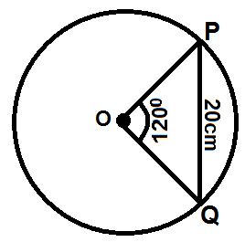

Determine the:

i) Shortest distance between the chord and the centre.

ii) Area of triangle POQ. (4 marks)

**SECTION B:**

11. a) Draw a graph of Y = (2x – 1) (x + 3) for -4 ≤ x ≤ 2; use a scale of 2cm for 1 unit on the x – axis and 1cm for 1 unit on the y – axis. (7 marks)

b) Use your graph to solve the equations.

i) 2x**2** + 5x – 3 = 0 (2 marks)

ii) 2x**2** + 4x – 4 = 0 (3 marks)

12. The following are marks of 35 students scored from a mathematics examination from a certain school.

|  |  |  |  |  |  |  |
| --- | --- | --- | --- | --- | --- | --- |
| 30 | 60 | 70 | 80 | 90 | 69 | 53 |
| 72 | 40 | 92 | 51 | 61 | 82 | 71 |
| 51 | 73 | 59 | 88 | 60 | 74 | 76 |
| 79 | 38 | 67 | 55 | 99 | 48 | 66 |
| 65 | 68 | 79 | 67 | 73 | 66 | 83 |

a) Construct a frequency distribution table starting with 30 – 39. (5 marks)

b) Calculate the mode. (3 marks)

c) Draw a cumulative frequency curve and use it to estimate the median mark. (4 marks)

13. a) Using a ruler, pencil and a pair of compasses only, construct a triangle ABC such that AB = 7.1cm, angle ABC = 105**0** and angle BAC = 45**0**. Measure the length AC.

b) Construct a perpendicular onto AC from B to meet it at D.

Circumscribe triangle BCD and measure the:

i) Length BD.

ii) Radius of the circle (12 marks)

14. The points A(-2, 1), B(-2, 4), C(1, 4) and D(1, 1) are vertices of a square ABCD. The images of A, B, C and D under a reflection in the line x – y = 0 are A’, B’, C’ and D’.

A’, B’, C’, and D’ are then mapped onto points A”, B”, C” and D” respectively under an enlargement with scale factor 2 and a centre of enlargement the origin (0, 0).

a) Write down the matrices for the reflection and enlargement. (2 marks)

b) Find the coordinates of the points:

i) A’, B’, C’ and D’. (3 marks)

ii) A’, B”, C” and D”. (3 marks)

c) Determine the matrix of a single transformation that would map ABCD onto A”, B”, C”, D”. (2 marks)

d) Show the square ABCD and its images on the same axes. (2 marks)

15. a) Given that , find the values of x and y. (4 marks)

b) A school bought sports wears of different sizes for different colours.

The order of sizes were, small, medium and large.

The colours were yellow, blue, green and red.

|  |  |  |  |
| --- | --- | --- | --- |
| Yellow | 20 small | 40 medium | 30 large |
| Blue | 50 medium | 10 small | 20 large |
| Green | 40 large | 35 medium | 5 small |
| Red | 32 medium | 35 large | 8 small |

If the cost was Shs 9,000, Shs 10,000 and Shs 12,000 for small, medium and large sizes respectively, write down a;

i) 4 x 3 matrix for the purchases. (2 marks)

ii) 3 x 1 matrix for the cost. (1 marks)

iii) Use matrix multiplications to determine the amount spent on buying sportswear for each colour. (5 marks)

16. Given that A and B are centres of the circles, lines PA and PB are tangents to the circles respectively.

PQ = 30cm while AB is a perpendicular bisector of PQ;

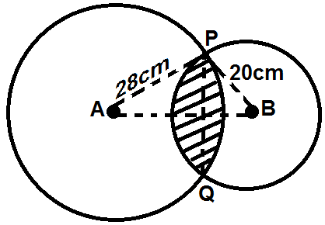

Find the area of the shaded part which is common to the two circles.

(Take π = 3.142)

17. Kiira Municipal council plans to construct a parking yard for X – minibuses and

y – Lorries. Minibuses are allowed 10m**2** of space and Lorries 20cm**2** of space and there is only 500m**2** space available.

Not more than 40 vehicles are allowed at a time. There are always both types of vehicles and at most 15 Lorries are allowed at a time.

a) i) Write down five inequalities to represent the above information.

(3 marks)

ii) Represent the above inequalities in (a) (i) above on the same axes.

(5 marks)

b) If the parking charges for the minibus is Shs 50,000 and that for a Lorry is Shs 60,000 per day. Find how many vehicles for each type should be parked on the yard in order to maximise profits.

**END**